# Issara Singtothong A1

Part 2: Write up

Repository :

https://github.com/Issara62/Java-Assignment---Mineral-Trump

# User Stories

* User Start application
* Show main menu with selection options
* Show instructions
* User exits program
* User chooses number of players
* Show dealer and give positions to players
* Show users hand
* User deals cards if assigned dealer
* User plays a card
* User draws a card / User passes turn
* User selects trump category
* User changes trump category
* Show which player’s turn it is
* Show user AI’s turn in play
* Show winner of game
* Build deck
* Table cards reshuffle into deck
* Left of dealer takes turn first
* Geophysicist and Magnetite cards allow instant win

# Testing Workflow

Main Menu

* The main menu loops until a valid selection is entered.
* The input for number of players has error checking for a max of 7 players.
* Instructions are available.

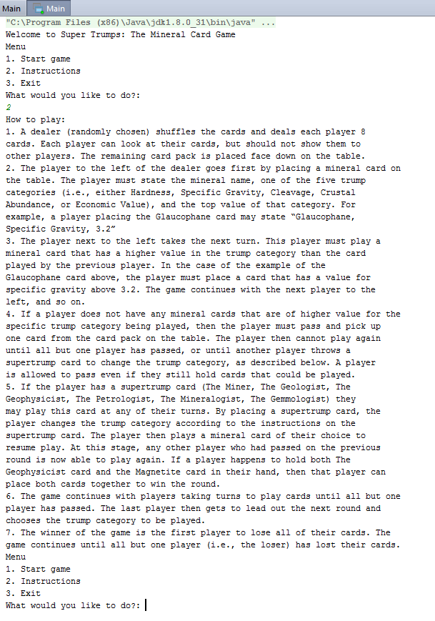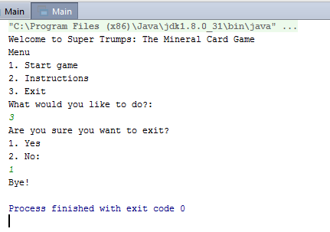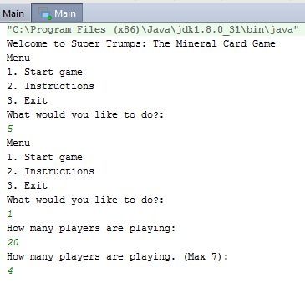

Gameplay

* Shows dealer / If human player is dealer
* Shows position of players
* Shows user’s hand
* Shows card that has been played
* Shows the card on the ‘table’
* Shows deck amount
* Shows how many people have skipped
* Shows trump value of card played vs card on the table

Other Features

* Table cards are dealt back into deck
* Ranking arrays for cleavage, crustal abundance, economic value
* Random positioning of all players

